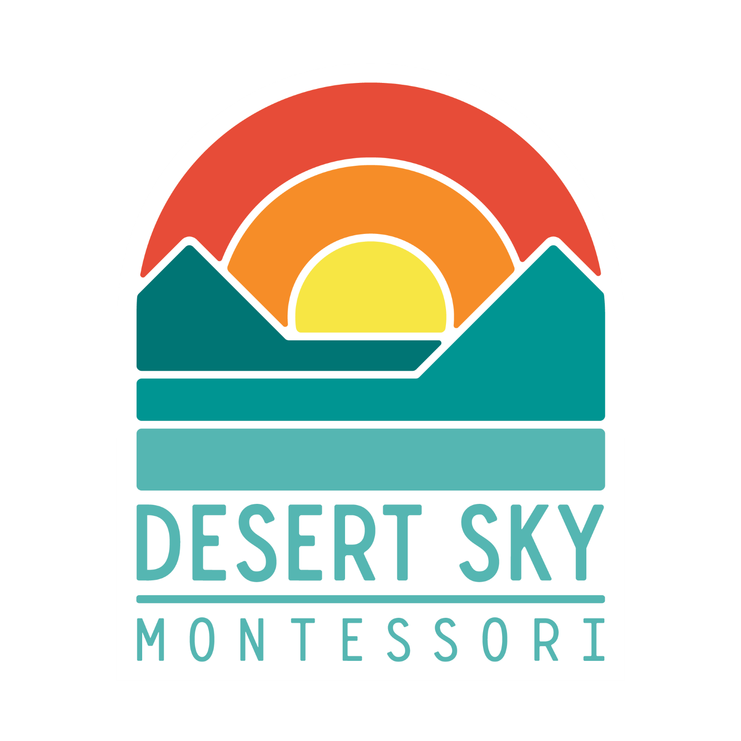
Desert Sky Montessori
Board Meeting Agenda
April 4th, 2022 at 1:30

CALL TO ORDER

Executive Session

