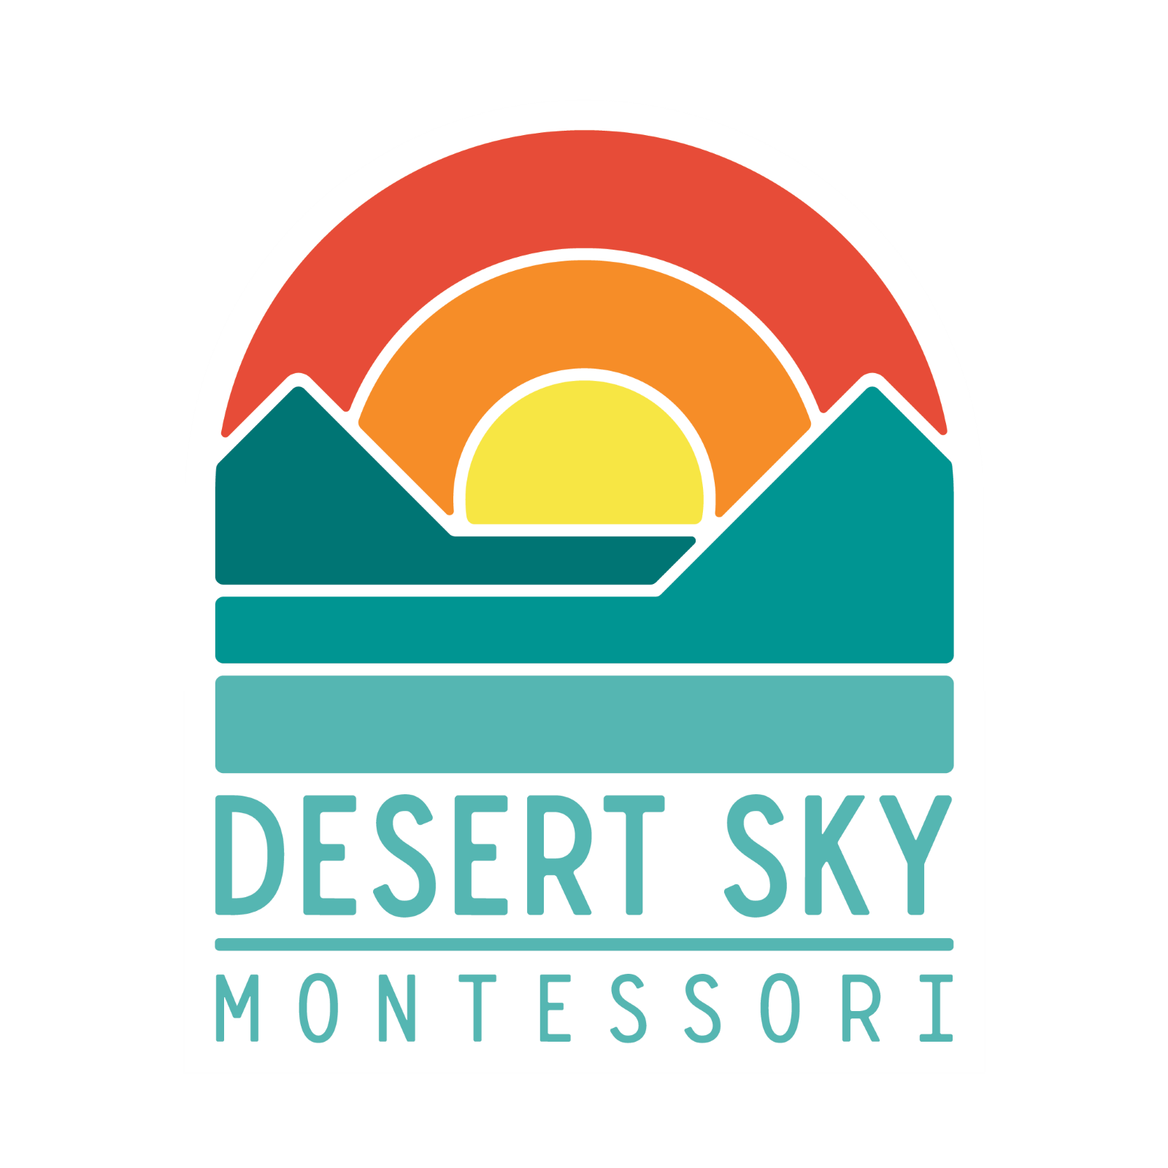
Desert Sky Montessori
Board Meeting Agenda
April 1st, 2022 at 1:30 pm

CALL TO ORDER

Executive Session

